Speaker Grilles On Or Off: Which Way Sounds Better?
by James Larson — February 18, 2019
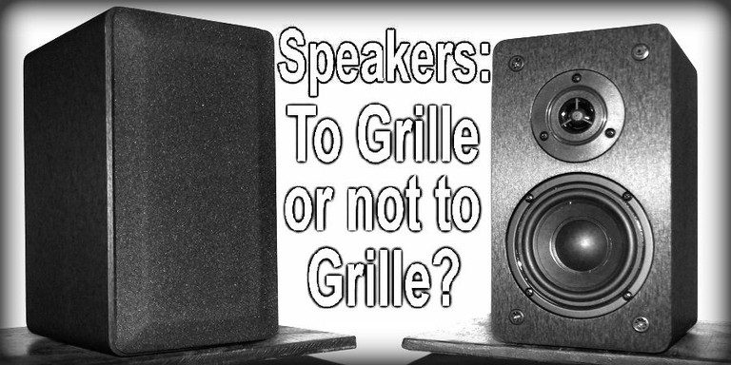
Let’s talk about loudspeaker grilles- you know, those things that cover the front of your speakers and make them look boring. Many people, for whatever reason, seem to prefer their loudspeaker appearance with the grilles on. But grilles aren’t just about the aesthetics of the speaker, they also protect it from harm and abuse- like say, a rambunctious child or pet who may otherwise damage the delicate cone of the woofer or dome of the tweeter. Most home audio loudspeaker grilles are removable though, so their use is optional for most domestic applications. Given how fussy audio enthusiasts can be, the use of grilles has been a point of strong personal preference for as long as there have been home audio loudspeakers.
Here at Audioholics, we have received many inquiries in the past pertaining to the impact of speaker grilles on the sound quality. More specifically, something along the lines of:
“Will my speakers sound better or worse with the grilles on?”
Since there are so many different speaker designs out there, the answer to that question could never be an absolute yes or no, at least without knowing the characteristics of that particular speaker. However, in our experience, grilles usually do not improve loudspeaker performance. In this article, we will explain how and why grilles tend to have an adverse effect on the speaker's performance, and we will also talk about how much they can actually spoil the sound quality.

Speaker Grilles On/Off YouTube Videos Discussion
in our experience, grilles usually do not improve loudspeaker performance.
In order to talk about how a grille can affect the performance, we have to talk about diffraction. Generally speaking, diffraction is how a wave is modified when it is deflected by some obstacle. In loudspeaker engineering, diffraction occurs when the sound waves reflect off the speaker enclosure. Very simply put, when the sound pressure wave is produced by the driver, it will disperse at a wide angle, unless the wavelength itself is not as large as the surface area of the diaphragm acting on the air, such as the woofer cone or tweeter dome. A good speaker is designed so that the diameter of the driver’s diaphragm is smaller than the wavelength being reproduced. This ensures wide-angle dispersion, instead of beaming like a flashlight. The sound waves can emanate at such a wide angle that it reflects off of the front baffle of the cabinet. The reflected sound waves from the front baffle of the speaker can reach the listener (or microphone) at a very slight time delay with respect to the sound coming directly from the driver diaphragm and cause comb filtering: cancellation and summation effects with the original sound.
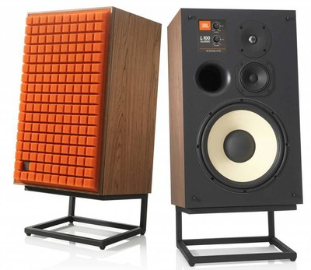
Revampled JBL L100 Speakers - Quadrex foam grille (left) vs no grille (right)
To restate loudspeaker diffraction more simply, it is when sound produced by the woofer or tweeter bounces off the front of the speaker and interferes with the sound coming directly from the woofer or tweeter. One important point to make here is that the wavelength of the sound frequency has to be shorter than the speaker’s baffle surface in order to be reflected, so bass frequencies that have long wavelengths don’t experience diffraction- they just bend around smaller obstacles and surfaces as though they weren’t even there. It is this reason why subwoofer grilles will not affect subwoofer sound at all; the wavelengths of those low frequencies are much larger than the speaker enclosure itself, let alone any grille frame. But sound waves of shorter wavelengths will be affected by the size of the front baffle- and everything on it, including the grille. The grille is just more “stuff”, acoustic obstacles, for higher frequency sound waves to diffract off of and cause interference patterns.
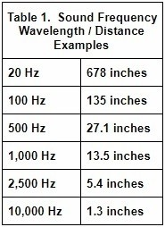
Table 1. Wavelengths of sound frequency examples.
Table 1 shows some examples of sound frequency wavelengths. We can see that the wavelengths at 1,000 Hz and below are too large to reflect off of a typical home audio speaker baffle, but 2,500 Hz and higher frequencies have wavelengths that are much more common sizes for speaker cabinet widths, and so are more likely to be subject to diffraction effects.
the grille frame plays a bigger impact on diffraction than the fabric itself.
We are not talking about the fabric that is often stretched over the frame of the grille; we are talking about the frame of the grille itself. The fabric does very little to interfere with the sound, assuming the fabric is tautly stretched over the frame. Most grille fabrics are acoustically transparent and generally do not affect the sound in an audible manner or even in a scarcely measurable manner. The fabrics might attenuate the sound slightly in very high frequencies, but the effects would be minor compared to the diffraction caused by the grille frame. The grille frame is a more substantial obstacle. Of course, not all grille frames are the same, and some are more obtrusive than others. A grille with a thick, protruding frame is going to cause a lot more diffraction than a grille with a slight, minimal frame. But the frame of the grille is frequently just a diffracting object which can cause the speaker to have a rougher frequency response than otherwise.
Pictured below are two grille frames: one that incurs a lot of diffraction (Fig. 1) and one that does not (Fig. 2). It can be seen that the thick grille in Figure 1 uses two layers of wood that add up to a half inch thick frame. The top layer of the frame is the more constricting of the two and its proximity to the drivers will increase the severity of diffraction. The frame of the grille in Figure 2 is very thin and keeps its distance away from the drivers. Furthermore, there is also some perforation in the grille frame that may help a bit as well. This grille barely affects the speaker’s response at all.
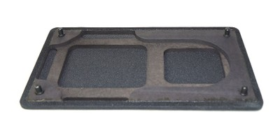
Figure 1. An example of a grille that will cause significant diffraction due to the thick and broad frame.
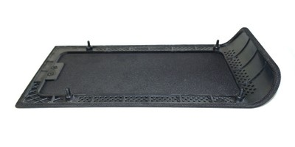
Figure 2. An example of a grille that does not cause much diffraction due to its thin frame.
To see how much grilles can affect speakers’ responses here is are a few examples of speakers from past reviews, picturing both the grilles and their response difference:
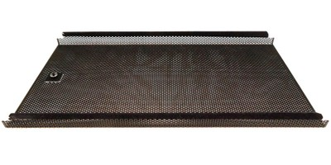
Figure 3. Outlaw Audio BLSv2 grille.
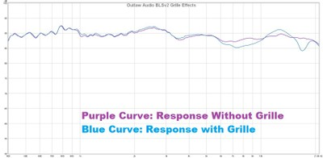
Figure 4. Outlaw Audio BLSv2 responses with and without the grille.
In Figure 3 and Figure 4 we can see the grille design of the Outlaw Audio BLSv2 and its effect on the response. The effects of the grille are evident but not severe on this excellent loudspeaker. This grille design isn’t acoustically invisible, but it isn’t an especially bad grille with respect to its effects on the response. One thing that sets this grille apart from others is that, as we mentioned in the review, it is really tough and does a superb job of protecting the drivers. Since the grille frame here is very slight, the major contributor to the grille’s deformation on the response may be comb-filtering from the perforation pattern of the metal grille. It should also be noted that the audibility of this effect on the response is very much in question since diffraction effects are not like steady-state resonances. This is discussed further below.
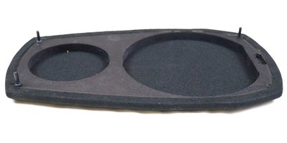
Figure 5. Dayton Audio MK402 grille.
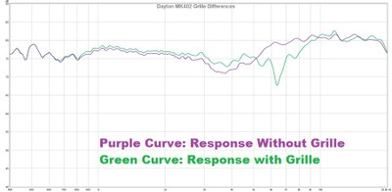
Figure 6. Dayton Audio MK402 responses with and without the grille.
Figure 5 and 6 show the grille design of the Dayton Audio MK402 and its effects on the direct response. The grilles use ½” thick MDF and do constrict the tweeter a bit. This is doubtlessly causing the very substantial dip just a bit over 6 kHz. As we will discuss below, this may not be causing as significantly audible effect on this response as would appear from the graph.
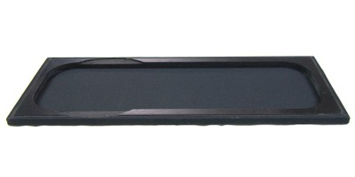
Figure 7. Philharmonic Audio BMR Philharmonitor grille.
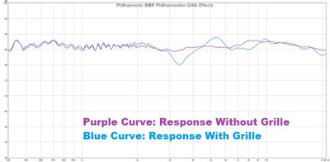
Figure 8. Philharmonic Audio BMR Philharmonitor response with and without the grille.
Figures 7 and 8 show the grille design of the Philharmonic Audio BMR Philharmonitor and its effects on the direct response. While the grille frame of the BMR Philharmonitor does keep its distance from the drivers, it is relatively thick and that is clearly having an effect on the response. Again, the audibility of diffraction is not likely to be a serious matter, as we will now discuss.

Impacts of Sound from Grille Diffraction
diffraction effects are significantly more audible in the nearfield than the farfield of the speaker.
Now let’s talk about the impact on the sound from the diffraction effects of grilles. One complication is that the angle and distance from the speaker will somewhat change the frequencies where these diffraction effects occur at. The sum total output of the speaker per frequency is not changed, but the output per frequency does become modified depending on distance and angle. Since the overall acoustic energy generated by the speaker per frequency remains the same, and also since much of what we normally hear from the loudspeaker is not just direct sound from the speaker itself but also the many acoustic reflections from the various surfaces of typical rooms, baffle diffractions effects may not be significantly audible in ordinary listening situations unless it is severe. Whatever the audibility if diffraction effects, in practice they are going to be more significant in the near-field than in the more reverberant far-field, since grille/baffle diffraction does not affect the speaker’s total acoustic power output. The audibility of diffraction is even more questionable in modern speakers that have relatively narrow cabinets. The point here is that while we can easily see the effects of the extra diffraction from grilles in these graphs that were measured in quasi-anechoic conditions, the effects would likely not be easily heard amidst in the acoustic conditions of ordinary in-room listening situations. What you hear from a sound system in a domestic environment is far more complex than what a microphone picks up in a reflection-free environment, and the diffraction effects of grilles would be more subtle.
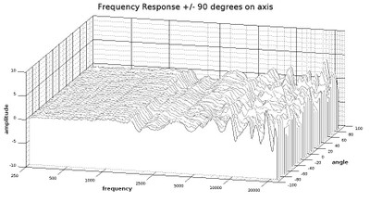
Figure 9. Infinity Primus P153 grille/no grille amplitude difference per angle
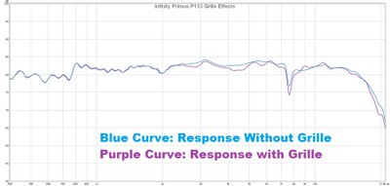
Figure 10. Infinity Primus P153 responses with and without the grille.
To get a more detailed look at how diffraction can affect the response, we took an Infinity Primus P153 and measured its horizontal response from a direct axis angle out to a 90-degree angle in five-degree increments with both the grille on and grille off. We choose the P153 for this because its grille differences are not as deleterious as many other speakers we had on hand, and we thought it would be better to show the kind of difference that a grille makes in a relatively good case; its responses with and without grille are shown in Figure 10. The grille for the Primus P153 is shown in Figure 2. The graph in Figure 9 shows the difference in amplitude that is caused by the use of the grille, so the areas where the curves stay close to zero on the vertical scale means that the grille isn’t causing any significant changes. However, areas where there is lots of fluctuation on the vertical scale mean that the grille is having a greater effect. We can see that up to just under 2 kHz, the grille is not doing much to the speaker’s response. Above 2.5 kHz, the grille’s effects become more prominent, and as we near 20 kHz, the grille is causing around 5 dB changes in amplitude. If we look closely, we can also see that the effects become more severe the further we move from the direct axis. This is a relatively benign grille, but we can still see how it is altering the sound. But again, we will repeat for emphasis: this looks much worse than it sounds.
While grille diffraction isn’t likely to be a major blight on the sound quality, that isn’t necessarily to say that the increased diffraction would be totally inaudible. A study conducted by Earl Geddes and Lidia Lee suggests that diffraction-like effects are audible, and that human hearing can perceive it as a nonlinear distortion since its presence increases in audibility as amplitude is raised¹. It isn’t clear how much this research pertains to the amount of diffraction that typical grilles can cause, but it does prevent us from declaring it to be absolutely inconsequential.

Audible Effects of Speaker Placement Near Adjacent Surfaces
actual bookshelves are not a good location to place bookshelf speakers.
What is likely a much greater source of diffraction in many setups is nearby objects and surfaces. For example, if you place your speakers in a shelf space such as in a bookshelf slot or cubby, as is shown in Figure 12, the acoustic effects of that are inevitably going to be far more damaging on the sound than almost any grille (ironically, actual bookshelves are not a good location to place bookshelf speakers). The surrounding surfaces in the cubby is certain to be a source of destructive reflections, especially if the speaker is pushed far back into the cavity. If your speaker is placed recessed on a shelf, desk, or table where there is a significant amount of surface space immediately under the speaker, as is shown in Figure 11, that is going to cause much worse problems than almost any grille. A lot of acoustic energy will reflect off of the tabletop surface to negatively impact combine with the direct sound of the speaker. Another common placement that will cause a lot of diffraction is if you place your speaker right next to a wall or in a corner, as is shown in Figures 13 and 14, because that will do substantially greater damage to the sound quality than a grille ever could in the same way as Figure 11 but at different angles. If you want to get the best sound out of your speakers, placement will count for a lot more than the use of the grille. Give your speakers some breathing room away from walls and corners and keep them away from surfaces. Also, have as few obstructions between you and the speaker as possible.
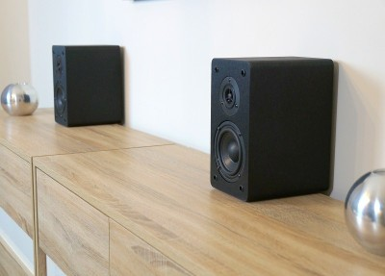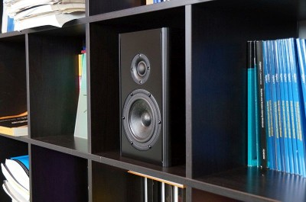
Figure 11 (left) and Figure 12 (right). Shelf space in front of the speaker will be a major source of diffraction in Figure 11.
Surrounding surfaces in the bookshelf will also create a lot of diffraction in Figure 12.
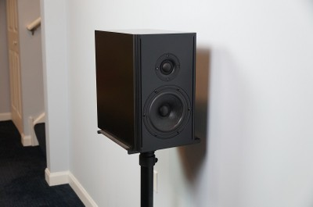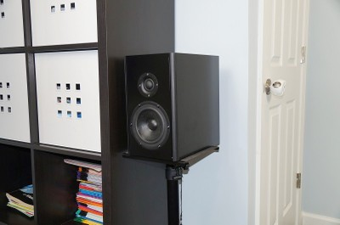
Figure 13 (left) and Figure 14 (right).
Placing speakers next to walls and in corners creates all kinds of acoustic problems, including diffraction effects that are bound to be much more significant than almost any grille.

Conclusion
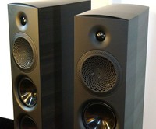Before closing our discussion of the effects of loudspeaker grilles, we should emphasize something we mentioned at the beginning of this article that while most speakers are designed to produce the best sound without grilles and therefore only provide grilles as a protective component that does compromise the sound, some speakers were engineered with the intention of grille use and have designed their speaker’s sound accordingly, such as Vandersteen’s speakers and the Paradigm Premier speakers that we dealt with recently. They do so by factoring in the grille frame as a part of the design and adjust the cabinet and crossover accordingly. In our experience, this is not the norm, but it can happen. Those who want to know for sure about a certain speaker model are advised to get in contact with the loudspeaker’s engineers for the best answer.
In the end, the question of whether the speakers will sound better with or without grilles leans toward the answer that most speakers technically perform better without grilles, but it can vary with speaker, and also the difference will likely be a subtle one if it can be heard at all.
Let us know in the related forum thread below how you listen to your speakers: Grilles On or Grilles Off?
¹Geddes, Earl R., and Lidia W. Lee. "Audibility of linear distortion with variations in sound pressure level and group delay."

